**ASSIGNMENT 6.1**

PROBLEM STATEMENT:

1) Create a database named 'custom'.

Output:

Query: hive> create database custom;



2) Create a table named temperature_data inside custom having below fields:

1. date (mm-dd-yyyy) format

2. zip code

3. temperature

Output:

Query: create table if not exists temperature data

(

date date,

zip int,

temperature int

)

row format delimited

fields terminated by ',';

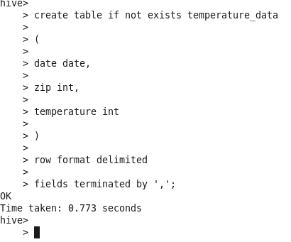

3) Load the dataset.txt (which is ',' delimited) in the table.

Output:

Query: LOAD DATA

LOCAL INPATH '/home/acadgild/hive/temperature_ data'

INTO TABLE temperature_data;

